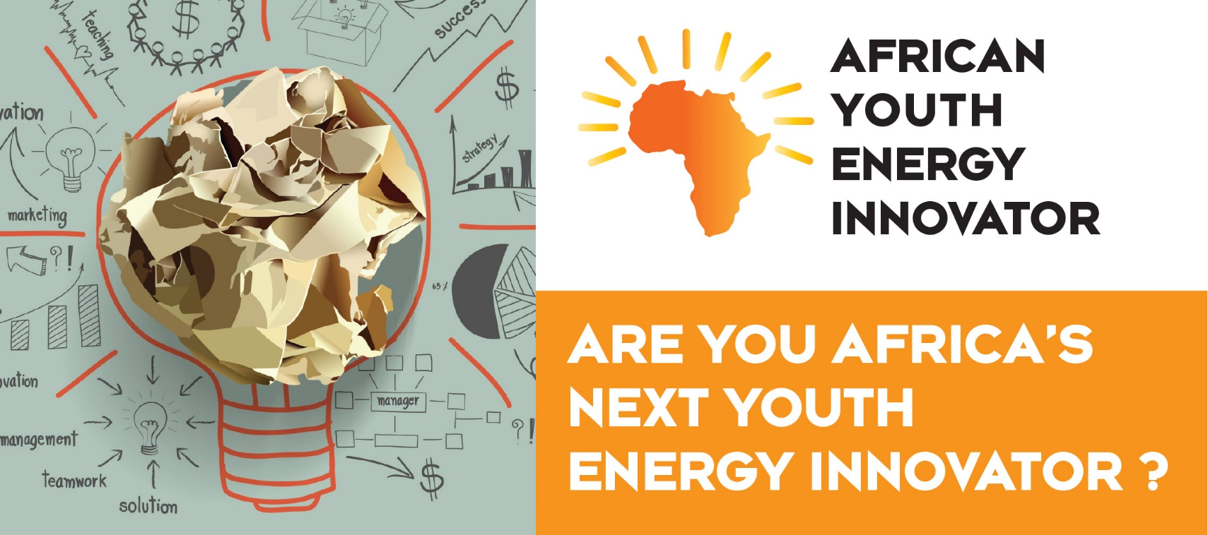

AFRICA YOUTH ENERGY INNOVATOR 2018
Proposal Submission Template
Please use this template for your proposal submission. Please note the following:
- Please include data where appropriate
- Include diagrams or pictures of your product if applicable
- Limit the total length of your proposal (Section 2) to a maximum of 4 pages
- All Sections are mandatory for completion
Section 1: Innovator Details
Innovator Name:
Institution/Company Name:
Innovation Title:
Country of Residence:
Nationality:
Age:
ID or Passport number:
email address:
Phone number:

Section 2: Product/Innovation description
Please describe your innovation in as much detail as possible. Ensure to address the qualification criteria in your product/innovation proposal. See checklist in Section 3 for qualification criteria.
The Product/Solution:

How the technology works:

Benefits of the Innovation:

Section 3: Checklist of Qualifying Criteria
Please fill in the checklist. Mark with Yes/No the criteria that your product/innovation addresses in your proposal.
Please complete each box with
Yes or No

Are you between 18 to 35 years old? | Yes
Does your innovation address these key areas (complete each box)
- Energy Security: Can your innovation help with effective management of energy supply, reliability of energy infrastructure, or meet a specific set of current and future demands?
- Environmental Sustainability: Does your innovation provide clean renewable or low carbon supply energy?
- Energy Equity: Can your innovation improve accessibility and affordability of energy in Africa?
- Job creation: Could your innovation create jobs?
- Target customers: Did you say which customers will benefit from your innovation? For example Utilities / Rural communities / Corporates etc.
- Customer value: Did you cover the key benefits of your innovation to customers?
- Your unique value proposition: Did you describe how you will you differentiate and position yourself?
- I have read and accept the conditions of the disclaimer

Disclaimer: If your idea is not patented, disclose only what your innovation does and not how it works. The Africa Energy Indaba organisers and evaluating panelists take no responsibility or accountability for loss of Intellectual Property. Submissions are made at the Innovators own risk. Africa Energy Indaba organisers reserve the right to utilize your submission content in media campaigns, i.e. website, mailers, press releases etc, as they see fit.

Please email your submission to deveena@energyindaba.co.za.

The deadline for submissions are 15 January 2018. No late entries will be accepted. In the subject line please write “Africa Youth Energy Innovator submission” and your name.

